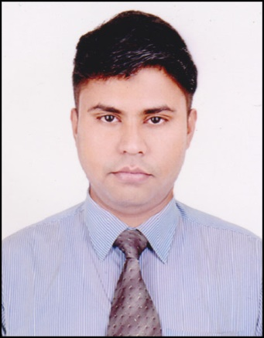

**MD.MOFIJUR RAHMAN**



mdanik373015@gmail.com



01918373015. 0000000000001834202260

**Career Objective**

To build up myself as a confident & potential person for the well fare of the people of Bangladesh by using my best knowledge & skill. To obtain a position to utilize my skills and abilities in any recognized company that offers job security and professional growth while being resourceful, innovative and flexible.



**Education**

**MBA** Appeared **Khulna University**

**BBA,Management** Graduated,2014 National University CGPA:2.69

**H.S.C, Busines Studies** Graduated, 2009Govt.M M.City College GPA- 4.20   
Jessore Board   
 Khulna.

**S.S.C, Business Studies** Graduated, 2007Khulna Zilla School GPA- 4.69   
Jessore Board   
Khulna.



**Professional Qualifications and Affiliations**

* **More than 5 years Marketing Job Experience.**
* **IELTS COURSE.**
* **6 month computer course.**
* **Driving License**.
* Good communication, presentation skills, smartness
* Excellent writing skills in both English & Bangla and verbal communication
* Excellent skills on computer operations
* Proficiency at building and maintaining internal and external relationships
* Leading contributor individually and as a team member
* Excellent skills in motivational and advocacy activities
* Ability to penetrate accounts and administrational activities



**Work Experience**

**MO(marketing officer)  
Feed & Chicks.**

**Date:26-4-2017 To 28-07-2019**

AREA: South Zone -2 ( Gopalganj, , Soriyotpur,)

AFIL AGRO.LTD (Akij Group)  
Head Office: Navaran, Chanchra Jessore.

***Duties/Responsibilities:***

* Monitoring Total Sales & Marketing.
* Assemble daily sales target to MO.
* Report to Head Office .



**Computer Proficiency**

* **6 Month Computer Course, Certificate**.
* Microsoft XP applications (Word, Excel, Office, PowerPoint)



**Languages**

* Bangla
* English



**Personal Interests**

|  |  |
| --- | --- |
| * Traveling * Spend time with family |  |



**Personal Details**

Father’s Name : Md. Mojibar Rahman

Mother’s Name : Marjia Begum

Date of Birth : JUNE 5, 1992

Gender : Male

Marital Status : Married

Nationality : Bangladeshi

Religion : Islam

Permanent Address : C/O: MD.Mojibar Rahman 61, Najirghat Main Road,Khulna. Dist. - Khulna

Current Location : 61, Najirghat Main Road,Khulna. Dist. - Khulna



**Reference**

|  |  |  |  |
| --- | --- | --- | --- |
|  |  | **Reference: 01** | **Reference: 02** |
| Name | : | Ahmed Ashique Raazi | SK. Waliar Rahman |
| Organization | : | NRB BANK. Khulna Main Branch | Prottasha (A Non-Government Organization) |
| Designation | : | Branch Manager | Chairman, |
| Address | : | Matribhasha Bhaban,63 KDA Avenue,Khulna,Bangladesh 9100 | Vill. - Deara (South Area), Post. - Deara (9220), P.S- Dighalia, Dist. - Khulna |
| Mobile | : | 01955544493 | 01955564606 |
| Relation | : | Relative | Relative |

**Declaration**

I, Md.Mofijur Rahman, hereby declare that the information contained herein is true and correct to the best of my knowledge and belief.

**Md. Mofijur Rahman**.